Food, Fun and Wellness
By Zach Salvo
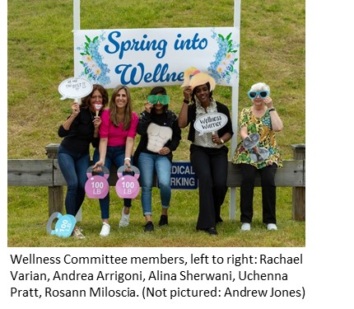
Danbury Mission Technologies held their Wellness Fair June 6, the first time since the pandemic hit in 2020. It was a day full of relaxation, fun, great food and a chance to meet colleagues, all catered toward the health and wellness of the employees.
Thanks to the fantastic Wellness Committee: Andrea Arrigoni, Andrew Jones, Rosann Miloscia, Uchenna Pratt, Alina Sherwani and Rachael Varian, the day went smoothly and was packed with fun.
“It was wonderful to come together with our colleagues to celebrate and support health and wellness at the Wellness Fair,” said Uchenna, who heads the Wellness Committee. “Thanks to everyone who participated and especially those who helped with the event. We look forward to doing it again next year!”
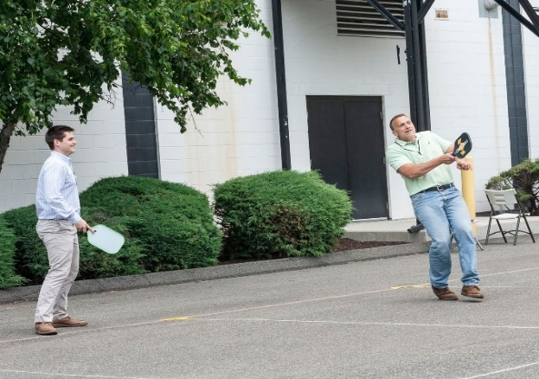
Vendors came to campus to showcase what they offer, like pickleball from a company called The Pickleball Barn. “Pickleball is a new, easy game to learn,” said Jeff Matusow, from The Pickleball Barn. “It’s fun and brings out the competitiveness in us. It’s always great to see people having fun playing the game.”
Danbury employees playing pickleball, pictured left-right: Andrew Kraus and Steve Nowacki
Danbury coworkers were able to showcase their athleticism and try something new.
Other vendors ranged from nutrition specialists, Dick’s Sporting Goods, a jewelry stand, and even a few booths run by some of our colleagues, such as our various sports teams, the Rising Professionals Network, and the super sweet and very popular caramel apple station.
“Just being able to spend time outside, spend time with coworkers and meeting new ones are just always great,” said Ling-Ling Olague, who ran the caramel apple station.
The fair gave employees a chance to take the edge off a busy day of work.
“It’s always a fun day and there is a lot to see,” said Vinny Brando.
“This is a very cool day, it’s always a great time,” echoed Randy Amos, who promoted the company’s volleyball team at the fair.
Whether you were helping at the fair or just stopping by to see what was going on, the fair brought many smiles and good times.
Click here to view more photos of the day.

