Killdeer Article
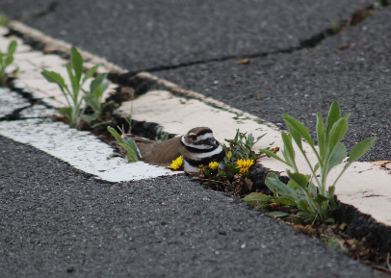
ARKA in Danbury has a new neighbor, temporarily that is! A Killdeer bird has made a home with her four eggs in the top corner of Danbury’s side parking lot.
Named for the call they make, which sounds a little like “kill deer,” the birds are known for nesting in some very inconvenient spots, at least to humans! They’re attracted to flat, open surfaces and sometimes gravel, which makes the Danbury parking lot a perfect spot for them to nest.
The Killdeer is protected in the U.S. by the Migratory Bird Treaty Act, meaning the nest cannot be moved without the government’s permission.

The nest is not to be disturbed during the 22-28 day hatching period of the eggs. The start of the hatching period for the Danbury eggs could not be confirmed, but they were discovered April X by Danbury engineer Jesse Booker. Placeholder for quote.
Killdeer will do anything to protect their nest, unleashing their very loud alarm call and even acting injured to keep intruders away from the nest. To protect the Danbury nest, we’ve placed cones at the nesting spot. We ask employees to make note of the location and take precautions to not disturb the nest, so the birds can eventually hatch and be on their way.
Want to listen to a Killdeer? Click here and scroll down to the audio clip.

